


Facilitate outgoing phone calls
D1.HFO.CL2.10
Trainee Manual






Facilitate outgoing phone calls

D1.HFO.CL2.10

Trainee Manual




Project Base
William Angliss Institute of TAFE
555 La Trobe Street
Melbourne 3000 Victoria
Telephone: | (03) 9606 2111
Facsimile: | (03) 9670 1330
Acknowledgements
Project Director: | Wayne Crosbie
Chief Writer: | Alan Hickman
Subject Writers: | Evelyn Collins and Linda Wilson
Project Manager/Editor: | Alan Maguire
DTP/Production: | Daniel Chee, Mai Vu, Jirayu Thangcharoensamut, Kaly Quach

The Association of Southeast Asian Nations (ASEAN) was established on 8 August 1967. The Member States of the Association are Brunei Darussalam, Cambodia, Indonesia, Lao PDR, Malaysia, Myanmar, Philippines, Singapore, Thailand and Viet Nam.
The ASEAN Secretariat is based in Jakarta, Indonesia.
General Information on ASEAN appears online at the ASEAN Website: www.asean.org.
All text is produced by William Angliss Institute of TAFE for the ASEAN Project on “Toolbox Development for Front Office, Food and Beverage Services and Food Production Divisions”.
This publication is supported by the Australian Government’s aid program through the ASEAN-Australia Development Cooperation Program Phase II (AADCP II).
Copyright: Association of Southeast Asian Nations (ASEAN) 2013.
All rights reserved.
Disclaimer
Every effort has been made to ensure that this publication is free from errors or omissions. However, you should conduct your own enquiries and seek professional advice before relying on any fact, statement or matter contained in this book. The ASEAN Secretariat and William Angliss Institute of TAFE are not responsible for any injury, loss or damage as a result of material included or omitted from this course. Information in this module is current at the time of publication. Time of publication is indicated in the date stamp at the bottom of each page.
Some images appearing in this resource have been purchased from stock photography suppliers Shutterstock and iStockphoto and other third party copyright owners and as such are non-transferable and non-exclusive. Clip arts, font images and illustrations used are from the Microsoft Office Clip Art and Media Library. Some images have been provided by and are the property of William Angliss Institute.
Additional images have been sourced from Flickr and SXC and are used under Creative Commons licence: http://creativecommons.org/licenses/by/2.0/deed.en
File name: TM_Facilitate_outgoing_phone_calls_refined.docx





Table of contents
Introduction to trainee manual 1
Unit descriptor 3
Assessment matrix 5
Glossary 7
Element 1: Identify elements and facilities of the host enterprise telephone system 9
Element 2: Demonstrate appropriate telephone communication skills 21
Element 3: Place outgoing calls on behalf of the enterprise 31
Element 4: Place outgoing calls on behalf of guests 41
Presentation of written work 47
Recommended reading 49
Trainee evaluation sheet 51
Trainee self-assessment checklist 53

Introduction to trainee manual

To the Trainee
Congratulations on joining this course. This Trainee Manual is one part of a ‘toolbox’ which is a resource provided to trainees, trainers and assessors to help you become competent in various areas of your work.
The ‘toolbox’ consists of three elements:
- A Trainee Manual for you to read and study at home or in class
- A Trainer Guide with Power Point slides to help your Trainer explain the content of the training material and provide class activities to help with practice
- An Assessment Manual which provides your Assessor with oral and written questions and other assessment tasks to establish whether or not you have achieved competency.
The first thing you may notice is that this training program and the information you find in the Trainee Manual seems different to the textbooks you have used previously. This is because the method of instruction and examination is different. The method used is called Competency based training (CBT) and Competency based assessment (CBA). CBT and CBA is the training and assessment system chosen by ASEAN (Association of South-East Asian Nations) to train people to work in the tourism and hospitality industry throughout all the ASEAN member states.
What is the CBT and CBA system and why has it been adopted by ASEAN?
CBT is a way of training that concentrates on what a worker can do or is required to do at work. The aim is of the training is to enable trainees to perform tasks and duties at a standard expected by employers. CBT seeks to develop the skills, knowledge and attitudes (or recognise the ones the trainee already possesses) to achieve the required competency standard. ASEAN has adopted the CBT/CBA training system as it is able to produce the type of worker that industry is looking for and this therefore increases trainees’ chances of obtaining employment.
CBA involves collecting evidence and making a judgement of the extent to which a worker can perform his/her duties at the required competency standard. Where a trainee can already demonstrate a degree of competency, either due to prior training or work experience, a process of ‘Recognition of Prior Learning’ (RPL) is available to trainees to recognise this. Please speak to your trainer about RPL if you think this applies to you.
What is a competency standard?
Competency standards are descriptions of the skills and knowledge required to perform a task or activity at the level of a required standard.
242 competency standards for the tourism and hospitality industries throughout the ASEAN region have been developed to cover all the knowledge, skills and attitudes required to work in the following occupational areas:
- Housekeeping
- Food Production
- Food and Beverage Service
- Front Office
- Travel Agencies
- Tour Operations.
All of these competency standards are available for you to look at. In fact you will find a summary of each one at the beginning of each Trainee Manual under the heading ‘Unit Descriptor’. The unit descriptor describes the content of the unit you will be studying in the Trainee Manual and provides a table of contents which are divided up into ‘Elements’ and ‘Performance Criteria”. An element is a description of one aspect of what has to be achieved in the workplace. The ‘Performance Criteria’ below each element details the level of performance that needs to be demonstrated to be declared competent.
There are other components of the competency standard:
- Unit Title: statement about what is to be done in the workplace
- Unit Number: unique number identifying the particular competency
- Nominal hours: number of classroom or practical hours usually needed to complete the competency. We call them ‘nominal’ hours because they can vary e.g. sometimes it will take an individual less time to complete a unit of competency because he/she has prior knowledge or work experience in that area.
The final heading you will see before you start reading the Trainee Manual is the ‘Assessment Matrix’. Competency based assessment requires trainees to be assessed in at least 2 – 3 different ways, one of which must be practical. This section outlines three ways assessment can be carried out and includes work projects, written questions and oral questions. The matrix is designed to show you which performance criteria will be assessed and how they will be assessed. Your trainer and/or assessor may also use other assessment methods including ‘Observation Checklist’ and ‘Third Party Statement’. An observation checklist is a way of recording how you perform at work and a third party statement is a statement by a supervisor or employer about the degree of competence they believe you have achieved. This can be based on observing your workplace performance, inspecting your work or gaining feedback from fellow workers.
Your trainer and/or assessor may use other methods to assess you such as:
- Journals
- Oral presentations
- Role plays
- Log books
- Group projects
- Practical demonstrations.
Remember your trainer is there to help you succeed and become competent. Please feel free to ask him or her for more explanation of what you have just read and of what is expected from you and best wishes for your future studies and future career in tourism and hospitality.

Unit descriptor
Facilitate outgoing phone calls
This unit deals with the skills and knowledge required to Facilitate outgoing phone calls in a range of settings within the hotel and travel industries workplace context.
Unit Code:
D1.HFO.CL2.10
Nominal Hours:
20 hours

Element 1: Identify elements and facilities of the host enterprise telephone system
Performance Criteria
1.1 Identify the types of outgoing calls that may be made and their importance to the business
1.2 Identify the components of the telephone system
1.3 Describe the functions and features available in the telephone system

Element 2: Demonstrate appropriate telephone communication skills
Performance Criteria
2.1 Interpret the enterprise policies and procedures for telephone use in regard to outgoing calls
2.2 Differentiate between face-to-face and over-the-phone communications
2.3 Use appropriate telephone communication skills
2.4 Use appropriate telephone techniques
2.5 Describe acceptable telephone etiquette

Element 3: Place outgoing calls on behalf of the enterprise
Performance Criteria
3.1 Obtain required telephone number and details of business/person to be called
3.2 Determine purpose of call
3.3 Place call and establish contact with required business/person
3.4 Explain purpose of call
3.5 Transfer connected call to caller
3.6 Facilitate conference calls
3.7 Implement standard re-dial procedures as required
3.8 Log details of call in accordance with enterprise procedures
3.9 Place emergency calls
3.10 Enter commonly called numbers into system speed-dial facility

Element 4: Place outgoing calls on behalf of guests
Performance Criteria
4.1 Greet guest and determine call to be made
4.2 Obtain required telephone number and details of business/person to be called
4.3 Place call and establish contact with required business/person
4.4 Implement standard re-dial procedures as required
4.5 Log details of call in accordance with enterprise procedures
4.6 Cost guest calls for posting to account

Assessment matrix
Showing mapping of Performance Criteria against Work Projects, Written Questions and Oral Questions
The Assessment Matrix indicates three of the most common assessment activities your Assessor may use to assess your understanding of the content of this manual and your performance – Work Projects, Written Questions and Oral Questions. It also indicates where you can find the subject content related to these assessment activities in the Trainee Manual (i.e. under which element or performance criteria). As explained in the Introduction, however, the assessors are free to choose which assessment activities are most suitable to best capture evidence of competency as they deem appropriate for individual students.
 |  |  | Work Projects | Written Questions | Oral Questions
Element 1: Identify elements and facilities of the host enterprise telephone system
1.1 | Identify the types of outgoing calls that may be made and their importance to the business |  | 1.1 | 1, 2 | 1
1.2 | Identify the components of the telephone system |  | 1.2 | 3 | 2
1.3 | Describe the functions and features available in the telephone system |  | 1.3 | 4, 5 | 3
Element 2: Demonstrate appropriate telephone communication skills
2.1 |  | Interpret the enterprise policies and procedures for telephone use in regard to outgoing calls | 2.1 | 6, 8 | 4
2.2 |  | Differentiate between face-to-face and over-the-phone communications | 2.2 | 7 | 5
2.3 |  | Use appropriate telephone communication skills | 2.3 | 9, 10 | 6
2.4 |  | Use appropriate telephone techniques | 2.1 | 11 | 7
2.5 |  | Describe acceptable telephone etiquette | 2.5 | 12, 13, 14 | 8
Element 3: Place outgoing calls on behalf of the enterprise
3.1 | Obtain required telephone number and details of business/person to be called |  | 3.1 | 15 | 9
3.2 | Determine purpose of call |  | 3.2 | 16 | 10
3.3 | Place call and establish contact with required business/person |  | 3.3 | 17 | 11
3.4 | Explain purpose of call |  | 3.4 | 18 | 12
3.5 | Transfer connected call to caller |  | 3.4 | 19 | 13
3.6 | Facilitate conference calls |  | 3.6 | 20 | 14
3.7 | Implement standard re-dial procedures as required |  | 3.7 | 21 | 15
3.8 | Log details of call in accordance with enterprise procedures |  | 3.7 | 22 | 16
3.9 | Place emergency calls |  | 3.9 | 23 | 17
3.10 | Enter commonly called numbers into system speed-dial facility |  | 3.10 | 24 | 18
Element 4: Place outgoing calls on behalf of guests |  |  |  |  |  |  |  | Element 4: Place outgoing calls on behalf of guests2
4.1 |  | Greet guest and determine call to be made | 4.4 | 25 | 19
4.2 |  | Obtain required telephone number and details of business/person to be called | 4.2 | 26 | 20
4.3 |  | Place call and establish contact with required business/person | 4.3 | 27 | 21
4.4 |  | Implement standard re-dial procedures as required | 4.4 | 28 | 22
4.5 |  | Log details of call in accordance with enterprise procedures | 4.5 | 29 | 23
4.6 |  | Cost guest calls for posting to account | 4.6 | 30 | 24

Glossary
Term | Explanation
Outgoing call | Telephone calls made by the establishment to external people or businesses
Emergency services | Services such as the fire brigade, ambulance, and police
Place a call | To make a call
Operator assisted call | When the operator makes a call for a person
Reverse charge | Phone calls where the charge is transferred back to the person being called rather than the caller
Person to person | When a caller only wants to talk to a specific person they place a person to person call
Transfer calls | Putting a call through to a different section. You must follow the transfer procedure
Automatic answer | When a phone call is answered by a computer and the caller has options to select
Speed dial | Pre-programmed numbers that dial with the touch of one or two keys
Conference call | More than one person on the line for the call. Callers can both hear and see each other
Call return | Calls are returned back to the switchboard for various reasons to be dealt with
On-hold | Callers hear music or advertising while they are waiting for the operator
No show | A guest who has a reservation but doesn’t turn up to the hotel or restaurant
Peak period | A time of the year when room availability is low because most of the rooms are sold
Policy | Statement about the venue's position on a particular issue. Could relate to code of conduct
IDD | International direct dialling - a telephone feature that enables guests to make international calls
Charge back facility | Ability to charge back to your room. Pre-established credit facilities
Automated system | A computer system or PMS requiring minimal handwriting
Free call line | A toll free telephone line whereby the venue pays the cost of the call
Free of charge (FOC) | No charge applied
Telephonist | Person whose job it is to answer all phone calls
Receptionist | Person who works on the front desk
Caller ID spoofing | The practice of causing the telephone network to display a number on the recipient's caller ID display that is not that of the actual originating station
Prank calls | False calls - calls made for a joke
Pulse | A means of putting a dollar value onto a phone call
PMS | Property management system - computer system for a hotel
Receiver | Handset of a telephone

Element 1:
Identify elements and facilities of the host enterprise telephone system

1.1 Identify the types of outgoing calls that may be made and their importance to the business

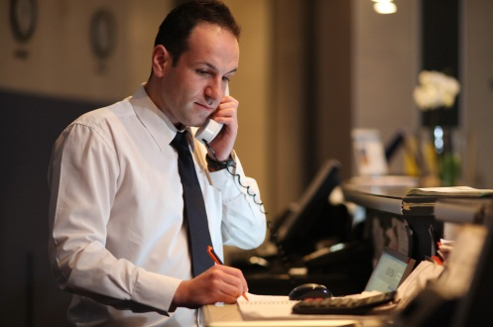
Introduction
The telephone is an important tool in any business and advances in telecommunications has enabled businesses to radically change the way in which they conduct their business over the phone. All staff need to be familiar with the host telephone system they are using in order to provide an efficient and professional service.

Types of outgoing calls
Within any given day many calls are made to outside businesses for various reasons.
Contacting suppliers
When contacting suppliers you will need to make sure the person you are talking to is the person who is able to help you. In most cases when we contact suppliers we will have created a rapport with the sales representative and they are familiar with the supplies we usually order and can assist you with an order.
If this is the first time you have contacted a supplier you will need to get the name of the representative you are talking to. In some cases sales representatives or contract managers are assigned to deal with the same clients or companies all the time. Knowing the name of the person who assists you is the first rule of receiving good service. When you call the supplier you should always ask for the person you deal with as they know you and your company's needs.
In some areas, particularly the kitchens in a restaurant, the stock is ordered at the same time every day. For instance, at 14.00hrs (2pm) after the lunch service, the supplier of bread is contacted to place the next day's order. If you don’t contact the supplier before 2pm they cannot produce the bread you need for the next day. If you deal with the same supplier all the time and they don’t get your daily call by 2pm they might even give you a call as a reminder because they know the order needs to be placed for the next day.
Keep your contact information updated with details of your suppliers’ representatives. If you know they don’t work on Wednesday then don’t call them on that day and waste your time.
For frequently called numbers, such as your suppliers, have the numbers programmed into your telephone system. This will save you time when you are calling them as you don’t have to look up a directory.
Contacting emergency services
There will be a time when you have to contact an emergency service and if it does you should be prepared.
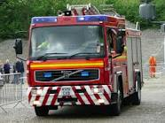
The receptionist or telephonist is likely to be responsible to call the emergency services which include the ambulance, fire brigade and police when an incident occurs. These numbers need to be displayed clearly near the phone or the switchboard. In some countries the number is as easy as 911 or 000; you must know the emergency services number for your city or country as well as having it prominently displayed. You should also have direct telephone lines to the local police station, or the closest fire brigade.
- Fire
When you call the fire department they will usually tell you what to do.
- They will ask the exact location and name of your establishment
- The nature of the fire
- Location of the fire within your property
- They might ask you if you have already started to evacuate people and recommend that you do this if you haven't already started
- Someone must remain at the switchboard at all times to convey instructions to the staff until:
- The fire alarm is declared a false alarm or
- You are in danger or
- You are advised to leave by a manager or fire warden
- Illness or accidents (ambulance or doctor)
You may need to make an outgoing call to convey information to receive assistance
- Remain calm
- Relay to the emergency services the nature of the illness or accident
- The more information you have at this point the greater the assistance you can give
- Pass on the information about the person, their name, room number or department and age if possible
- Let management know about the situation
- Advise the guest or other person taking charge what action has been taken, such as the ambulance or doctor is on their way.
- Police
- In the case of any abuse or fighting hotel security should be able to deal with the situation. However, there are times when things can get out of hand and you will need to call in the police
- You will call the emergency number, identify the establishment and let the police know where they are to go and what the trouble is
- Notify your security or the manager on duty that the police are on their way.
Placing personal or private calls
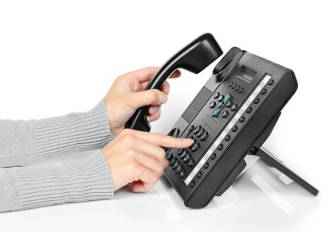
In some instances you will be asked to place a call to a particular location or company. Usually when a receptionist or telephonist is asked to place a call it is because the call is a difficult one to make. For instance, it is hard to get through to a particular international country or the person is busy doing something else and requires a third person to make the call and let them know when it comes through. This is referred to as an "operator assisted call". There are several reasons why a guest might require an operator assisted call:
- Guest is unfamiliar with the telephone system
- Unsure how to place call themselves
- Wanting to place a reverse charge call
- Wanting a long distance person to person call.
It is important you know how quickly to connect them to the telephone number they have requested.
When placing a call we need to know:
- The name of the person or business being called
- Telephone number to call - or you need to find this out for the person
- Country code and area code, where applicable.
Before dialling the number you will need to keep the original guest or person on hold then dial the appropriate number. In some cases you may have to do this several times to get through to the country or the appropriate guest. Let the guest know who you are calling for:
“Good morning. This is Linda from Asea Hotel. We are calling for Mr. Armstrong who would like to speak with Mr. Collins”.
When Mr. Collins comes to the line, you ask him to hold and call Mr Armstrong to let him know you have his caller for him and then transfer the call to Mr. Armstrong.
Marketing and sales activities
Most of the sales and marketing activities will take place over the phone. Today the use of mobiles makes this an easy thing to do anywhere and everywhere. Marketing and sales need to promote the venue’s services and facilities with the intention of attracting customers. They can do this by sending text messages to guests who are on a mailing or text list. They can let the customers know about up and coming sales or promotions that are taking place. This has opened up a whole new field of marketing opportunities.
If you are calling someone from your database, get all the information in front of you before you make the call. Whether you are using a computer software program, a PDA or a Rolodex, this will be an aid to your memory and enables you to store notes you make during the call. All this adds to the service you are providing and saves you time as well as increasing your revenue.

Confirmation reservations
As most people today have a mobile phone you can use the telephone system to automatically send a confirmation to a guest to remind them they have a restaurant reservation at 8pm or a room booking for next Wednesday night with the expected arrival time of 18.00hrs. There is usually a phone number included to confirm these details. This improves your business as we are less likely to get no show guests and can fill the hotel or the restaurant to maximum capacity.
Making reservations

The telephonist will make outgoing calls to make reservations for various guests at many different establishments.
Before making the call on behalf of the guest you will need to obtain some information:
- Name of the guest
- Contact details such as room number or mobile number
- Reservation information such as the number of guests, time requested, dietary requirements.
Make sure you leave a message (written, text or phone call) for the guest to let them know that their reservation has been made successfully. This is providing that extra bit of service to the guests that they will remember about your hotel and hopefully choose to come back and use it again.
The telephone system might eliminate the need for an actual person to answer the phone and provide an automated answer for the outlets and facilities you are calling. For example:
"Thank you for calling Asean Hotels. If you would like to make a reservation for this evening select "1" now. If you would prefer to make a reservation for another date press "2" now. If you are confirming or changing a reservation press “3" now. Otherwise, please hold and an operator will be with you shortly."
For places that you call frequently, city sights tours or the local theatre, have the phone numbers programmed into your telephone system as this will save time when you are with the guest.
Follow-up a variety of situations
Outgoing calls are required to follow up situations. It is good practice to follow up situations within 24 hours of it occurring because if you wait too long the person thinks you have forgotten to follow up.
Some telephone systems allow for automated follow up to occur such as sending a text to a mobile number.

Responding to complaints
When a guest complains they want to be taken seriously. They require an immediate response. They want the situation resolved and someone to listen to them. By having this complaint we have an opportunity to win the customer back again so we need to handle it effectively and efficiently.
When responding to complaints:
- Determine what the complaint is: it could be something that can be resolved easily. Get the right person to call them back and respond to the complaint
- Acknowledge the issue: express concern and apologise on behalf of the establishment. Try not to blame anyone in particular
- Let them know what action will be taken: the person you have called might want something like a sincere apology, a complimentary item or a refund. You might be able to do this immediately or will have to call the guest back
- Make sure you follow up with what you said you would do: passing the complaint onto a supervisor or sending something in the mail.
Returning calls:
Return calls promptly.
If at all possible, make your outgoing telephone calls in "prime time". Research has shown that more people are in their offices early in the morning and can be reached between 8am and 11am.
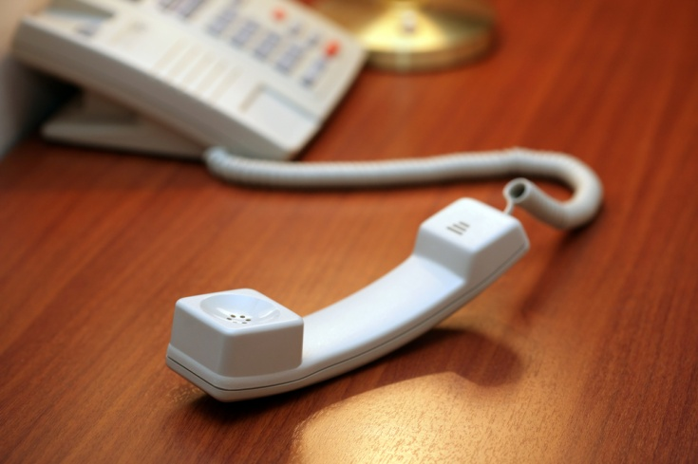
If you are trying to reach someone or returning their call and they are not answering leave a detailed message of what you want to say. There is no point leaving repeated messages on a person's answering machine. Make sure you allow a reasonable amount of time to call back, such as the next business day.

1.2 Identify the components of the telephone system

Introduction
The telephone is still the primary communications tool for most businesses so it is important to have a telephone system that suits your business.

Mobile phones

Mobile phones (also known as cellular phones) are a tool that can make and receive calls all over the world. This has opened up the amount of time you can use a phone for business as you are no longer required to be stationed in your office.
The mobile phone provides a greater service than just being able to receive and make calls. It allows for text messaging, MMS, email, internet access, short-range wireless communications (Bluetooth), business applications and even photography.
Smart phones can allow you to process business orders and relay them back to the office for distribution while you are still with the client. Smart phones save money and save time.
Mobile phones have enabled guests to make their own outgoing calls which have substantially reduced the income made by hotels in the past when the hotel directed all phone calls and charged the guest for this service and revenue was earned.

Paging systems
A paging system is a two way radio that is used to maintain contact within a large organisation such as large hotels, resort locations, or places where staff move around a lot in their work and need to be contacted.
Typically porters, housekeeping supervisors, security or duty managers would carry a paging system so they can be contacted at all times while they are on duty.
The control panel of the paging system is usually maintained in one location. It could even be a function of the switchboard.
When the staff member carrying the pager is required a message is sent to the pager number, telling them what is required of them. Some two way pagers allow for the staff member to speak to the person at the control panel, similar to a telephone call only a lot cheaper.

Switchboards

A switchboard is a piece of equipment that allows an establishment to manage several telephone lines and multiple extensions at once.
Today’s switchboards are vastly more sophisticated than the original switchboard invented with the option of having many tasks automated such as answering the phone, wake up calls, taking messages and providing promotional material.
A switchboard is a telephone system that must be able to:
- Receive and make several calls at once
- Record messages for extension numbers
- Interface with other software packages to record calls and associated charges
- Transfer calls
- Play on hold music or advertising material
- Place calls on hold.
In the past all calls that were being made from a venue passed through the switchboard. Switchboards were a source of income for hotels by charging guests for their telephone calls.

Handset and head sets
The headset has become invaluable in the office as it is more comfortable than holding a telephone for long periods of time and frees up the person’s hands to take notes and process data.
There are many varieties of headsets available on the market today
- Wireless (cordless), Bluetooth and corded headsets
- Headsets with sound tube and multi-directional microphones for quiet environments!
- Headsets with standard and ultra-noise cancelling microphones for noisy environments!
- Headsets with mono and dual speakers!
- Headsets with multiple wearing styles; over-the-head, over-the-ear and behind the head!
On a telephone the handset is a device the user holds to the ear to hear the audio sound. Modern-day handsets usually contain the phone's microphone as well, but in early telephones the microphone was mounted directly on the telephone itself, which often was attached to a wall at a convenient height for talking. Handsets on such telephones were called receivers.
Websites for handsets and headphones:
- https://panasonic.ca/english/accessories/handsets/index.asp
- http://www.headphone.com/
- http://store.apple.com/ca/browse/home/shop_ipod/ipod_accessories/headphones.

Caller identification (ID) facilities
If you have Caller ID facilities attached to your phone, then an amazing thing happens every time your phone rings. The number (and sometimes even the name) of the calling party appears on the display right after the first ring!
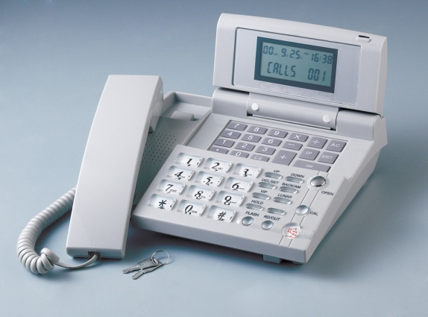
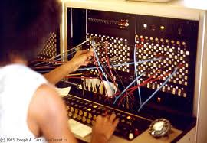
Caller ID may be used to track down or limit the impact of telemarketers or prank calls, and other annoyances. However, it can also impede communication by enabling users to become evasive. The concept behind caller ID is the value of informed consent. However, it also poses problems for personal privacy. Another problem is that the possibility of caller ID spoofing makes it unreliable. Caller ID spoofing is the practice of causing the telephone network to display a number on the recipient's caller ID display that is not that of the actual originating station.
VIP utilises the screen to provide clear indication of phone line and caller status. Super bright coloured LEDs and an ergonomically friendly button layout give a concise overview and control of all callers at a glance. The VIP caller ID integrates unique features like "Busy All Lines" and control of the "Auto Attendant" feature, which answers calls and plays out a custom message before parking calls on hold.

1.3 Describe the functions and features available in the telephone system

Introduction
No longer is a telephone just a telephone. Today’s telephone systems may include single and multiple lines, switchboards, landlines, or mobiles.

Caller ID display
When a call comes in or goes out the caller ID is displayed. This enables you to identify the caller. An application transmits the number of the called party's telephone equipment during the ringing or when the call is being set up before the call is answered.
Where available, caller ID can provide the name associated with the calling telephone number.
The information made available to the called party may be displayed on a telephone's display, on a separately attached device, or be processed by an attached computer with appropriate interface hardware.
Caller ID may be used to display a caller's telephone number (and, in association with a database, name) on a called user's telephone. This works in most countries; although systems are incompatible, each country will have appropriate equipment.

Call return
Call return, or last call return as it is also known, is a telephony feature offered by a telephone service provider to give a called party the time and telephone number of the last received call, and may also offer the facility to place a call back to the calling party.
The general public tends to refer to the service by the telephone feature code or the telephone number it has in their country.
Call return can also mean when a call is not answered the call can be returned to the switchboard for the operator to try another number or take a message for the person called.

Transfer and transfer recall
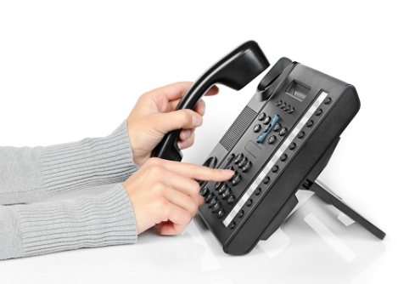
The skill of transferring a call does not only depend upon the understanding of the establishment’s telephone equipment but also requires a courteous and professional manner.
In most cases, when a person calls an establishment they will expect to be transferred. However, this transfer must work efficiently for the caller. Do not send them to the wrong department, do not cut them off in the process and do not allow the guest or caller to repeat themselves to everyone that answers the phone. Make sure you know how to correctly transfer a call.
Procedure to transfer a call
- Answer the incoming call according to establishment procedures
- Find out who the call is for
- Let the caller know you are going to transfer them. Give them a chance to object if they want and this will also let them know where they are being transferred to
- When the phone is answered identify yourself, let them know you are transferring a call, tell the person what the caller wants (don’t let the guest have to repeat themselves) using maybe even the caller's name if you have it, and hang up.
Transfer recall
If you transfer a call and do not wait for someone to pick up the call at the other end most telephone systems will allow for transfer recall. That is, the call will bounce back to you if it is not answered by a person or an answering/voicemail machine. If this is the case then you must let the caller know that the other area is unavailable and give them the option of leaving a message or calling back.
Likewise if the line is engaged or after a programmed number of rings the call will transfer back to the operator again advising the guest of their options.
Placing calls "on hold"
Most telephone systems have the ability to play an advertising message or music when a call is placed on hold or before it answers.
Calls are placed on hold because there is a bank up of calls and the operator is busy.
Sometimes calls are put on hold manually, for instance, when you need to get some information for the guest you will inform them that they are going to be put on hold while you collect this information or speak to a supervisor. It is good practice to advise the guest what you are doing.
If a caller is on hold don’t forget to keep coming back to them to let them know what is happening. For instance, the line they are waiting for is still busy - do they want to call back or leave a message?
Multiple chat facilities and conference call
A conference call is a telephone call in which the calling party wishes to have more than one called party listening in to the audio portion of the call. The conference calls may be designed to allow the called party to participate during the call, or the call may be set up so that the called party merely listens into the call and cannot speak while it can also be set up to view the other caller. This is sometimes called Tele-Conference.
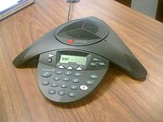
Conference calls can be designed so that the calling party calls the other participants and adds them to the call. However, participants are usually able to call into the conference call themselves by dialling a telephone number that connects to a "conference bridge" (a specialised type of equipment that links telephone lines).
Companies commonly use a specialised service provider who maintains the conference bridge, or who provides the phone numbers and PIN codes that participants dial to access the meeting or conference call.
The more limited Three-way calling is available (usually at an extra charge) on home or office phone lines. For a three-way call, the first called party is dialled. Then a button (or recall button) is pressed and the other called party's phone number is dialled. While it is ringing, flash/recall is pressed again to connect the three people together. This option allows callers to add a second outgoing call to an already connected call.
Speed dial
Speed dial is a function available on many telephone systems allowing the user to place a call by pressing a reduced number of keys. This function is particularly useful for phone users who dial certain numbers on a regular basis.
In most cases, the user stores these numbers in the phone's memory for future use. The speed dial numbers are usually accessed by pressing a pre-determined key or keys on the phone, followed by a one or two-digit code which the user assigns to each number. However for ease of use, on many systems a call may be placed by pressing and holding one key on the numeric keypad.
The numbers are programmed by the subscriber through the standard telephone dial, and speed dial calls are placed by dialling simply the digit and waiting a few seconds on a standard rotary dial phone and an older 10 key Touch Tone phone, or by dialling the number and the # key to instantly connect the call on a modern 12 key Touch Tone phone.
Automatic re-dial
In a telephone system, an automatic redial is a service feature that allows the user to dial the previous number called by depressing a single key or a few keys. This helps to save time if you are calling a number that is constantly engaged.
Work Projects
It is a requirement of this Unit that you complete Work Projects as advised by your Trainer. You must submit documentation, suitable evidence or other relevant proof of completion of the project to your Trainer by the agreed date.
1.1. Discover the advantages of marketing your property over a telephone system. See what information you can discover by using the internet to help you with this
1.2. Research a brand of paging system and identify its features
- Research a brand of switchboard and describe the features that are available. Find out the price of this equipment from a supplier in your city
1.3. Research how you can connect a conference call. Identify the brand and type of equipment that would be used.

Summary

Identify elements and facilities of the host enterprise telephone system
The telephone is an important tool in any business and advances in telecommunications has enabled businesses to radically change the way in which they conduct their business. All staff need to be familiar with the host telephone system they are using in order to provide an efficient and professional service
The telephone is still the primary communications tool for most businesses so it is important to have a telephone system that suits your business. We can use a mobile phone, a paging system, or switchboard
No longer is a telephone just a telephone. Today’s telephone systems may include single and multiple lines, switchboards, landlines, or mobiles, with direct dialling, caller ID, transfer re-call, on hold facilities, speed dial, automatic re-dial even multiple chat and conference facilities.

Element 2:
Demonstrate appropriate telephone communication skills

2.1 Interpret the enterprise policies and procedures for telephone use in regard to outgoing calls

Introduction
Within the front office it is important that we follow correct telephone communication skills whether we are responding to internal or external incoming calls. We answer the calls according to the organisation’s standards and enterprise policies and procedures.

Enterprise policies and procedures
Privacy and confidentiality
At all times the guests’ calls are private and confidential. Every hotel will have its own policies and procedures to ensure this remains clear to all staff.

Many hotels have created a "Privacy policy statement" relating to how and what they do with the personal information collected from guests. Such statements explain and outline the possibility that guests might have questions about how the hotel collects and uses the information that is provided by the guest. The statement verifies that, although the guest is asked at various times to provide information including but not limited to, details such as their name, email address or information about what they like and do not like. This information is only used to enhance services offered and to personalise products and services that the hotel thinks will interest the guest.
Information collected about a guest while using the telephone remains within the hotel and is confidential.
Staff are made aware of their responsibility in keeping guest details private and confidential by references to these policies and procedures in the staff handbook. Reception staff are in a position of obtain most of the information about guests and therefore need to be made fully aware of their responsibilities to the guests’ privacy.
Staff can often be tempted to pass on information about celebrities or prominent people to newspapers and magazines when these guests are staying at their hotel. Consequently staff need to be continuously reminded of their duty and responsibility to guests and the consequences, some of which could be legal action, if they break this privacy and confidentiality clause.

Restrictions on personal use of business telephone
Most hotels will have restrictions on staff using the business telephone during their working shift for anything other than hotel business.
Instructions on these policies and procedures will be detailed and recorded in the staff handbook which is given to every employee on the commencement of their employment.
Certain phone numbers will also be banned from being called during your shift such as 1300 numbers and inappropriate sites numbers.
Costing of telephone calls
Calls made by either staff or guests are charged according to the number of units or "pulses" (sound that represents a unit of time and therefore a dollar value) and which creates a charge for the call.
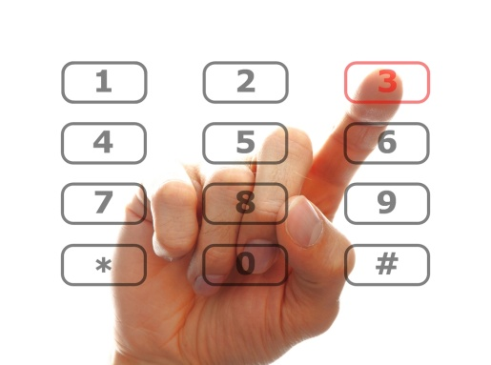
When a guest makes a call it is charged directly to the guest’s account or folio if the property is using a PMS (property management system). Otherwise, a charge is recorded manually and posted to the guest’s folio. An automated system will reduce the possibility for errors.
For internal staff telephone usage the cost of the call is registered against the department from where the call was made. This allows management to keep track of the cost of calls made by staff.
Standard phrases
The application of standard phrases for staff to use when answering the phone will ensure a professional standard is projected and maintained. This should include a standard greeting identifying the establishment, so the caller knows they have called the right place.
A standard phrase should be:
- A suitable greeting
- Identify the establishment
- Identify yourself
- Offer of assistance.
If the caller needs to be transferred to another department, it is important to find out what they want so they can be transferred to the correct place.
Examples of phrases are:
Staff: “Good morning, Singapore Grand hotel, this is Sally. How may I help you?”
Caller: "Can you put me through to room 2014 please"
Staff: “Certainly, may I have the guests name please?"
Caller: "It is Mr. Bolton-Smyth"
Staff: "Thank you, I will put you through now"
Or
Staff: "Good evening Bangkok Peninsular Hotel, this is Tom. How may I help you?"
Caller: "I would like to make to make a reservation in your restaurant please"

Staff: "Did you want the Main Dining Room or the Brassiere?”
Guest: “The Main Dining Room please"
Staff: “One moment and I will connect you
Or
Staff: "Good afternoon Bali Beach Resort, this is Milly. How may I help you?"
Caller: "Yes, Milly, My name is Dan, and I need some information about your function facilities?"
Staff: "Dan, I will transfer you to Kamal who is the functions manager and will be able to help you.”
Caller: "Thanks Milly, that sounds fine".
Training requirements:
Because the telephone systems used today can do so much it is essential that all new staff are trained in the use of the system. The best way is to have a supervisor acting as mentor for the new staff member and they are rostered onto the same shifts for at least the first month.
All staff need to be trained in emergency procedures especially the front office staff as they will be in the front line if an emergency does occur. Regular Fire evacuations and emergency practice needs to be scheduled by management.
Role of the telephone in the Emergency Management Plan (EMP)
Front office and the telephone play a major role in the EMP.
- The responsible manager must develop and maintain a formal and identifiable list of contact phone numbers in addition to the standard phone numbers provided below for use during an incident. The phone number contacts shall include:
- Local and regional medical practitioners
- Local and regional hospitals
- Environmental Protection Authorities and Agencies
- Local and regional contractors and equipment providers
- They will be responsible for calling the Emergency services and someone must remain at the switchboard at all times to convey instructions to the staff.
- The front office is responsible to distribute notification to house guests advising them of when a fire evacuation practice is scheduled and notifying the guests of where they are to find the "Evacuation Meeting Point". The telephonists will get a lot of calls about this and will need to keep the guests informed of what is happening and where they have to go.

2.2 Differentiate between face-to-face and over-the-phone communications

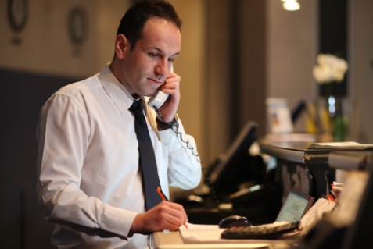
Introduction
In modern society, with the rapid development of technology, people have more choices of the ways to communicate with each other such as face-to-face, letters, emails, or telephones. Each method has its own advantages and disadvantages.

Face-to-face telephone communication
- First of all, communication face-to-face means they can get responses immediately without misunderstanding
- During face-to-face conversation, people can not only hear responses from others, but also see their expressions and gauge how they are feeling. This might let you know you need to supply more information as the person is confused
- Face-to-face communication allows people to use eye contact. This helps get an understanding of where the communication is at, offering a greater richness of information
- Body language will add to the communication in a face-to-face situation. Experts say that more than seventy percent of people of communication is made up of body language
- A face-to-face conversation will last longer as the more people talk together, the stronger and better the relationship they have
- Telephone communication will require a greater use of questioning skills than face-to- face
- Human beings prefer face-to-face communication if they have an option.

2.3 Use appropriate telephone communication skills

Introduction
Effective telephone communication involves skills that combine good verbal skills with unobtrusive telephone techniques. Poor telephone skills will very quickly put someone off if they are trying to do business with you. Conversely, an excellent telephone technique will not compensate for poor verbal communication skills. The key to success is in finding a balance between the two.
Positive attitude and speaking skills
- To convey a helpful and positive attitude you will need to feel comfortable with your job
- You need to be fully trained on the equipment you are using and have adequate product knowledge to answer all the questions put to you
- Know the suitable phrases you will need to use
- Attitude and enthusiasm are reflected by energy
- Avoid using jargon (workplace terms instead of real words)
- Don’t be verbose (use too many words)
- Avoid local language, dialects or slang.
Use your voice effectively including tone and volume
- Use your voice effectively. Some of us have more authoritative voices while others have quiet soft voices. Try and project a middle of the range voice
- The rate at which you speak can affect your voice - try not to be too slow or too fast
- Speak directly into the mouth piece. Adjust the headset to make sure it is suitable
- If your pitch is too monotone or too high it can be undesirable
- Keep your voice at a reasonable volume - louder doesn’t mean clearer
- Your tone should vary along with inflections - but try and keep it sounding normal
- Sit up straight and be comfortable in your working environment
- Your voice should reflect a professional image
- You should have a smile in your voice.
Apply listening and questioning skills
Listening skills
- Give the caller your full attention
- Make sure your mind is focused on the job
- Let the caller finish before you begin to talk
- Let yourself listen before you begin to talk
- Listen for the most important points.
Questioning skills
- Ask the right question
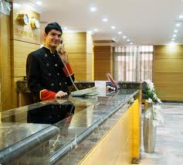
- Don’t use closed questions - unless you need a "Yes, No" response
- Use open questions - questions that will give you answers. This way you will receive more information. The best way is to start all your questions with: How, when, where, why or what.
Respond professionally
- Use the pre-planned phrases for greetings
- Have all the information you are likely to need close at hand
- Have a "can do" approach and attitude
- Avoid inappropriate expressions.

2.4 Use appropriate telephone techniques


Introduction
Well-developed telephone techniques will display an impression of professionalism and provide excellent service.
Clarify caller requirements
Use your questioning and listening skills to clarify what the caller has requested.
Repeat names, dates and times
Whenever guests give you details like their name make sure you spell it correctly. If you are not sure about the spelling then ask the guest to spell it. Read the letters back to the guest for clarification. Using the phonetic alphabet will help with a misunderstanding of letters being heard over the phone.
When you are given dates always read the dates back to the guest to confirm the details. In the case of time use a 24 hour clock to ensure there are no discrepancies between mornings, afternoons and evenings.
Phonetic alphabet
Phonetic Alphabet
A - Alpha  B - Bravo  C - Charlie  D - Delta  E - Echo  F - Foxtrot  G – Golf  H - Hotel | I - India  J - Juliet  K - Kilo  L - Lima  M - Mike  N - November  O – Oscar  P - Papa | Q - Quebec  R - Romeo  S - Sierra  T - Tango  U - Umbrella  V – Victor  W - Whisky  X - X-ray | Y - Yankee  Z - Zulu

2.5 Describe acceptable telephone etiquette

Introduction
Telephone etiquette requires answering the phone promptly, speaking clearly, using a suitable opening phrase, listening to the guest’s requests and processing the call in a professional manner.

Telephone Etiquette
- Answer the call within the second or third ring
- Always speak clearly and slowly
- Avoid extreme volumes
- Avoid jargon or hotel terminology
- Speak with a smile on your face
- Use an appropriate opening phrase
- Repeat the details back to the guest
- Always use the caller's name if known, otherwise, sir or madam
- Ask how something is spelled if you can’t understand
- Transfer calls promptly
- Never eat, drink or smoke while on the phone
- Use a suitable closing phrase - thank the caller for calling
- Always allow the caller to hang up first.

Work Projects
It is a requirement of this Unit that you complete Work Projects as advised by your Trainer. You must submit documentation, suitable evidence or other relevant proof of completion of the project to your Trainer by the agreed date.
2.1. Research policies and procedures relating to land lines and compare this to digital policies and procedures
2.2. Establish for yourself the difference between face to face communication and telephone communication. Record at least 5 reasons
2.3. Research listening skills and questioning skills - record your findings
2.4. Translate the phonetic alphabet into your local language
2.5 Design a handbook to give to new staff, emphasising the policies and procedures relating to telephone skills and etiquette.

Summary

Demonstrate appropriate telephone communication skills
Within the front office it is important that we follow correct telephone communication skills whether are responding to internal or external incoming calls. We answer the calls according to the organisation’s standards and enterprise policies and procedures
In modern society, with the rapid development of technology, people have more choices of the ways to communicate with each other such as face-to-face, letters, emails, or telephones. Each method has its own advantages and disadvantages
Effective telephone communication involves skills that combine good verbal skills with unobtrusive telephone techniques. Poor telephone skills will very quickly put someone off if they are trying to do business with you. Conversely, an excellent telephone technique will not compensate for poor verbal communication skills. The key to success is in finding a balance between the two
Well-developed telephone techniques will display an impression of professionalism and provide excellent service
Telephone etiquette requires answering the phone promptly, speaking clearly, using a suitable opening phrase, listening to the guests’ requests and processing the call in a professional manner.

Element 3:
Place outgoing calls on behalf of the enterprise

3.1 Obtain required telephone number and details of business/person to be called

Introduction
Calls are made for a variety of reasons. Whatever the reason, when placing an outgoing call we must follow the correct telephone etiquette using our telephone skills.


Outgoing calls
When making outgoing calls on behalf of an enterprise, unless the client or guest knows the numbers they need, you will have to consult a directory.
Directories can be:
- Internal - a listing of all departments’ extensions and numbers
- Client directories - a listing of all the clients an enterprise has
- External directories - either electronic or hard copy - using external listings to find the number required by the enterprise
- Local directories
- Regional directories
- International directories
- In some countries you can use ‘directory assistance’ - where an external operator will assist you to get the details needed for the call.

3.2 Determine purpose of call

Introduction
When placing outgoing calls you will need to determine the purpose of the call.

Determine purpose of call
- Returning a call or following up on a previous request or message
- Making a enquiry - clarifying information, checking on what is available
- Seeking information
- Selling and marketing activities to promote the enterprise.

3.3 Place call and establish contact with required business/person

Introduction
Placing an outgoing call requires you to dial the required number and make sure you are connected to the appropriate person or business.

Establish contact
Once you have been connected to the number you requested or dialled the person at the other end should also be following acceptable telephone etiquette and answer the phone with an appropriate greeting and give the name of the establishment.
Once you have established that you have the correct business ask to be put through to the required person you are seeking.
For example:
Dial the enterprise
Call is answered:
"Good morning, Somerset House Enterprise, Sonya speaking, how may I help you?'
You reply:
“It is the High Quality Hotel calling on behalf of Mr. Buxton; we want to speak to Mr. Morton in Security please"
Enterprise:
“Yes, I will put you through"
You to Mr. Morton:
"Hello Mr Morton, I have Mr Buxton on the line for you, one moment and I will put him through"
You to Mr. Buxton:
"Mr. Buxton, Mr. Morton is on the line. I will connect you now."
This way you have established contact and made it perfectly clear who is calling who and put the call through as requested.

3.4 Explain purpose of call

Introduction
When placing outgoing calls you will need to explain the purpose of the call.

Explain purpose of call
- Returning a call or following up on a previous request or message
- Making a enquiry - clarifying information, checking on what is available
- Seeking information
- Selling and marketing activities to promote the enterprise.

3.5 Transfer connected call to caller

Introduction
The skill of transferring a connected call to a caller requires a complete understanding of the workings of the telephone equipment you are using.

Transfer connected call
In the example of the call being made to Mr. Morton previously once you have been put through to him you will need to follow procedures to transfer the connected call.
Make sure you let Mr. Morton know what you are doing.
For example: “Hello Mr Morton, I have Mr Buxton on the line for you, one moment and I will put him through"

Using the telephone system put Mr. Morton on hold.
Open up the line for Mr. Buxton - letting him know what you are doing.
"Mr. Buxton, Mr. Morton is on the line. I will connect you now."
Now you put the Mr. Morton’s call through and open up the line so Mr. Buxton can speak to him and you LEAVE the line for them to continue with their business.

3.6 Facilitate conference calls

Introduction
Facilitating a conference call is simple. If you know how to use the phone you should have no problem. Conferencing is a well-known way to put together a meeting between people that are not in the same geographic area. Whether it be a meeting between co-workers that need to discuss a project or between you and a client to discuss a problem, if you know how to make a conference call, it can save both sides’ time and money.
Conference calls
Teleconferencing can be done through an audio conference call using only the telephone or through the web if you need to share files or visual aids. Since most companies have resources for outbound conference calls via the phone, that is what we will cover here.
First of all, you need to schedule the audio conference call for a time that is convenient for all parties. When you are teleconferencing with people in different geographic areas, it is essential to remember that they may be in different time zones and schedule your call for a time that falls near normal working hours for all parties. Once you have your list of attendees and time you will find that it is not so much how to make a conference call but the etiquette of what you do on the call that matters.
Before The Conference Call
Prior to the audio conference call, you want to make sure that you have appointed someone to take minutes of the meeting. They might write information down with a pad and paper or type it in directly. Either way, you want to be sure they mute their phone so their note taking does not disturb the conference. You need to schedule the time with your conference call service - they will give you a number and a password that you will use for the call. Be sure to pass this along to all attendees in your invitation to the audio conference call. About 10 minutes before the conference call, you need to test this number and password to be sure it works and if not take the appropriate action.
During The Call
You want to be sure to be prompt for your conference call so login a few minutes ahead of time so you can be on the line when new people join in. Keep a list of everyone who is supposed to be on the call and check their names off as they join. Some of them may be gathered together in a conference room and it is a good idea to have them mute their phone until one of them needs to speak. This will block out excess noise from people talking and shuffling papers. Also, if people are teleconferencing from home, have them mute their phones as well. There's nothing more distracting than trying to hold a business meeting while kids are screaming in the background!
After The Call
When ending the call, be sure to go over any action items and add them to the to-do list. Put these in the minutes from the meeting and send to all attendees. This is also a good time to schedule any follow up audio conferences if needed so all attendees can agree on a time.

3.7 Implement standard re-dial procedures as required

Introduction
Standard redial procedures are common place on telecommunications systems of today.
An automatic telephone redialling system and method applicable to a dial-type communication device is to provide an automatic telephone redialling procedure on phone numbers previously dialled by a user but which failed to get through to the receiver.
The advantages of this automatic telephone redialling system and method are that the user does not have to activate the redialling procedure manually, and the redialling procedure can be performed periodically for one or more phone numbers.

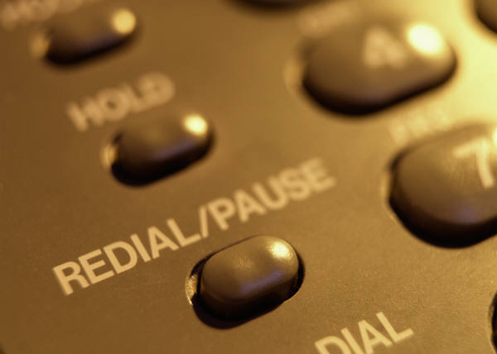
Redialling
To dial a number that you have previously dialled, press the 'Redial' button. The screen will display:
Pressing the 'Redial' button will cycle through the last 5 numbers you called
Press the '#' key to dial the selected number.

3.8 Log details of call in accordance with enterprise procedures

Introduction
A computerised telephone system will interface into the hotel PMS and automatically log all the details of a guest’s call. However, if you don’t have a PMS then this will have to be done manually via a log book of all outgoing calls.

Log details of calls
Details of outgoing calls that need to be logged are:
- Record the date and time the call was placed
- Record the details of any overseas calls
- Record the name of the business/person called
- Duration of the call especially for international and long distance calls
- Record the guest name and room number.

3.9 Place emergency calls


Introduction
The receptionist or telephonist is likely to be responsible for calling the emergency services which are the ambulance, fire brigade and police when an incident occurs. It is essential that all staff know how to place emergency calls.
Make sure you clearly display the phone numbers of the Emergency Services on the switchboard. In some countries the number is as easy as 911 or 000. You must know the emergency services number for your city or country as well as having it prominently displayed. You should also have direct telephone lines to the local police station, or the closest fire brigade.

Identify the nature of emergency
Fire
- When you call the fire department they will usually tell you what to do
- They will ask the exact location and name of your establishment
- The nature of the fire
- Location of the fire within your property
- They might ask you if you have already started to evacuate people and recommend that you do this if you haven't already started
- Someone must remain at the switchboard at all times to convey instructions to the staff until:
- The fire alarm is declared a false alarm or
- You are in danger or
- You are advised to leave by a manager or fire warden.
Ambulance/Doctor
Illness or accidents
- We will need to make an outgoing call to convey information to receive assistance
- Remain calm
- Relay to the emergency services the nature of the illness or accident
- The more information you have at this point the greater the assistance you can give
- Pass on the information about the person, their name, room number or department and age if possible

- Let management know about the situation
- Advise the guest or other person taking charge, what action has been taken.

Police:
When there is violence, aggressive behaviour, or any trouble that your hotel security cannot manage, it might be necessary to call the police to your property for assistance.
- Be calm and make the call to the authorities, let them know where in the hotel the trouble is. Give them a contact name if you have one, for example, the name of the security manager
- Let security know the police are on their way.

3.10 Enter commonly called numbers into system speed-dial facility

Introduction
As a means of saving time and for greater efficiency it is essential to enter any commonly called numbers into your speed dial facility.

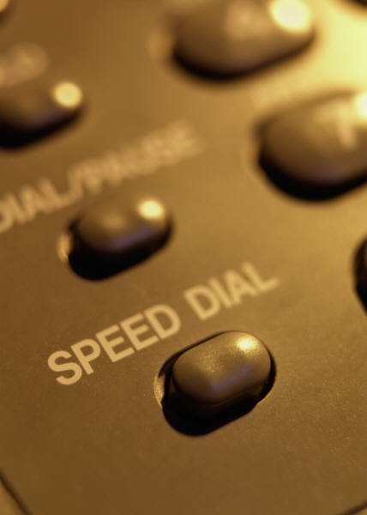
Speed dial facility
If your speed dial facility uses codes such as a one or two digit number to apply the redial function make sure you have a listing of the codes equal to the numbers for all staff to use.
Once you have been working in a place for a few weeks you will automatically know these codes. Remember, you will always have new staff or an emergency when someone might need to call this number, so have a coded chart near the switchboard at all times.

Work Projects
It is a requirement of this Unit that you complete Work Projects as advised by your Trainer. You must submit documentation, suitable evidence or other relevant proof of completion of the project to your Trainer by the agreed date.
3.1. Research what phone directories are available in your city
3.2. Describe the information needed to place an outgoing call to an enterprise in another country
3.3., 3.4. & 3.5. Describe why an establishment would make a call about "seeking information", explain the purpose of this call and discuss how you would transfer the call to the enterprise
3.6. Research brands of conference call telecommunications equipment and software that is available in your city. Include at least 3
3.7. List brands of telephones that provide redial facilities and describe how to enter numbers to enable the redial function. Include at least 2
3.8. From the equipment you looked at in Question 3.7 describe how the phone calls are logged with this equipment
3.9. Research where the local emergency services are in your area and provide contact numbers
3.10. Describe how you enter commonly called numbers into your mobile phone.

Summary

Place outgoing calls on behalf of the enterprise
Calls are made for a variety of reasons. Whatever the reason, when placing an outgoing call we must follow the correct telephone etiquette using our telephone skills
When placing outgoing calls you will need to determine the purpose of the call
Placing an outgoing call requires you dial the required number and make sure you are connected to the appropriate person or business
When placing outgoing calls you will need to explain the purpose of the call
The skill of transferring a connected call to a caller requires a complete understanding of the workings of the telephone equipment you are using
Facilitating a conference call is simple. If you know how to use the phone you should have no problem. Conferencing is a well known way to put together a meeting between people that are not in the same geographic area. Whether it be a meeting between co-workers that need to discuss a project or between you and a client to discuss a problem, if you know how to make a conference call, it can save both sides time and money
An automatic telephone redialling system and method applicable to a dial-type communication device is to provide an automatic telephone redialling procedure on phone numbers previously dialled by a user but which failed to get through to the receiver
A computerised telephone system will interface into the hotel PMS and automatically log all the details of a guest’s call. However, if you don’t have a PMS then this will have to be done manually via a log book of all outgoing calls
The receptionist or telephonist is likely to be responsible to call the emergency services, that is, the ambulance, fire brigade and police when an incident occurs. It is essential that all the staff know how to place emergency calls
As a means of saving time and for greater efficiency it is essential to enter any commonly called numbers into your speed dial facility.

Element 4:
Place outgoing calls on behalf of guests

4.1 Greet guest and determine call to be made


Introduction
When making outgoing calls for guests you will need to answer the phone with the establishments greeting phrase and use your questioning and listening skills to determine the details of the call that needs to be made.

Determine call
When making outgoing calls on behalf of a guest there are several questions that need to be asked:
- What is the number to be called?
- If the guest doesn’t know you will need to consult a directory
- Directories may be manual or computerised
- What country is that in?
- Is there a particular person you wish to speak to?
- Where will you put the call through to the guest?
- Are they in their room? - obtain the room number
- Or located somewhere else? - obtain the phone number
- Is this to be charged to their room or reverse charge call?
The telephone operator provides a service to the guest when placing outgoing calls.

4.2 Obtain required telephone number and details of business/person to be called


Outgoing calls
When making outgoing calls on behalf of a guest, unless the guest knows the number they want to call you will have to consult a directory.
Directories can be:
- Internal - a listing of all the department extensions and numbers
- Client directories - a listing of all the clients an enterprise has
- External directories - either electronic or hard copy - using external listings to find the number required by the guest
- Local directories
- Regional directories
- International directories
- In some countries you can use ‘directory assistance’ - where an external operator will assist you to get the details needed for the call.
You might need to know the details of the business to be called.
- Is it open at the time the call is placed?
- What country is it in? - It might be in a different time zone that you are.

4.3 Place call and establish contact with required business/person

Introduction
Placing an outgoing call requires you dial the required number and make sure you are connected to the appropriate person or business.

Establish contact
Once you have been connected to the number you requested or dialled the person at the other end should also be following acceptable telephone etiquette and answer the phone with an appropriate greeting and give the name of the establishment.
Once you have established that you have the correct business ask to be put through to the required person you are seeking.

For example:
Dial the business
Call is answered:
"Good afternoon, Hawthorn Manufacturing, Philip speaking, how may I help you?'
You reply:
“This is the Eclipse Hotel calling on behalf of Mr. Todd; we want to speak to a Mr. Snyder in Marketing please".
Business:
“Yes, I will put you through".
You to Mr. Snyder:
"Hello Mr Snyder, I have Mr Todd on the line for you, one moment and I will put him through".
You to Mr. Todd
"Mr. Todd, I have Mr. Snyder for you I will connect him you now."
This way you have established contact and made it perfectly clear who is calling who and put the call through as requested.

4.4 Implement standard re-dial procedures as required

Introduction
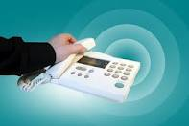
Standard redial procedures are common place in today’s telecommunications systems.
An automatic telephone redialling system and method applicable to a dial-type communication device is to provide an automatic telephone redialling procedure on phone numbers previously dialled by a user but failed to get through to the receiver.
The advantages of this automatic telephone redialling system and method are that the user does not have to activate the redialling procedure manually, and the redialling procedure can be performed periodically for one or more phone numbers.

Redialling
To dial a number that you have previously dialled, press the 'Redial' button. The screen will display:
- Pressing the 'Redial' button will cycle through the last 5 numbers you called
- Press the '#' key to dial the selected number.

4.5 Log details of call in accordance with enterprise procedures

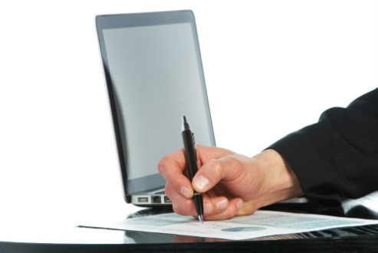
Introduction
A computerised telephone system will interface into the hotel PMS and automatically log all the details of a guest’s call. However, if you don’t have a PMS then this will have to be done manually via a log book of all outgoing calls. All calls need to be logged in accordance with enterprise procedures.

Log details of calls
Details of outgoing calls that need to be logged are:
- Record the date and time the call was placed
- Record the details of any overseas calls
- Record the name of the business/person called
- Note the duration of the call, especially for international and long distance calls
- Record the guest name and room number.

4.6 Cost guest calls for posting to account

Introduction
Calls made by guests are charged according to the number of units or "pulses" (sound that represents a unit of time and therefore a dollar value) which creates a charge for the call.
When a guest makes a call it is charged directly to the guest’s account or folio if the property is using a PMS (property management system) Otherwise, a charge is recorded manually and posted to the guest’s folio. An automated system will reduce the possibility or errors.

Hotel phone calls
Many hotels will charge a surcharge for making a call, whether or not the call is connected.
Some hotels can charge a surcharge from 50c to $7.30 for each time the guest picks up the phone to make a call, even if the call doesn’t connect. Surcharges are huge money-makers for the hotel.
When a call is made from the room phone the charge plus a surcharge is accumulated and automatically posted onto the guests’ folio via the PMS. The charge is posted onto the folio with details of the date and time of the call as well as the number called. This way the call is clearly displayed for the guest to check it.

Work Projects
It is a requirement of this Unit that you complete Work Projects as advised by your Trainer. You must submit documentation, suitable evidence or other relevant proof of completion of the project to your Trainer by the agreed date.
4.1 Debate whether guests use hotel telephones more than they use mobile phones. Provide reasons for and against for both
4.2. Using an International directory record the country codes for 8 countries in your region
4.3. Research how you place a call from your city to the United States. Document each step
4.4. Enquire into this website and document the benefits of this switchboard system. Detail the function for re-dialling calls
- http://www.solutions4business.co.za/8844/11107.html
4.5 Design a manual log book to record the telephone charges for a small 7 bedroom hotel
4.6 Research the internet and discover how many people complain about the cost of the surcharge placed on telephone calls. Record the rates of surcharges being charged.

Summary

Place outgoing calls on behalf of guests
When making outgoing calls for guests you will need to answer the phone with the establishment’s greeting phrase and use your questioning and listening skills to determine the details of the call that needs to be made
When making outgoing calls on behalf of a guest, unless the guest knows the number they want to call, you will have to consult a directory
Placing an outgoing call requires you to dial the required number and make sure you are connected to the appropriate person or business
An automatic telephone redialling system and method applicable to a dial-type communication device is to provide an automatic telephone redialling procedure on phone numbers previously dialled by a user but which failed to get through to the receiver
A computerised telephone system will interface into the hotel PMS and automatically log all the details of a guests call. However, if you don’t have a PMS then this will have to be done manually via a log book of all outgoing calls. All calls need to be logged in accordance with enterprise procedures
When a guest makes a call it is charged directly to the guests account or folio. Many hotels will charge a surcharge for making a call, whether or not the call is connected.

Presentation of written work

1. Introduction
It is important for students to present carefully prepared written work. Written presentation in industry must be professional in appearance and accurate in content. If students develop good writing skills whilst studying, they are able to easily transfer those skills to the workplace.

2. Style

Students should write in a style that is simple and concise. Short sentences and paragraphs are easier to read and understand. It helps to write a plan and at least one draft of the written work so that the final product will be well organised. The points presented will then follow a logical sequence and be relevant. Students should frequently refer to the question asked, to keep ‘on track’. Teachers recognise and are critical of work that does not answer the question, or is ‘padded’ with irrelevant material. In summary, remember to:
- Plan ahead
- Be clear and concise
- Answer the question
- Proofread the final draft.

3. Presenting Written Work
Types of written work
Students may be asked to write:
- Short and long reports
- Essays
- Records of interviews
- Questionnaires
- Business letters
- Resumes.
Format
All written work should be presented on A4 paper, single-sided with a left-hand margin. If work is word-processed, one-and-a-half or double spacing should be used. Handwritten work must be legible and should also be well spaced to allow for ease of reading. New paragraphs should not be indented but should be separated by a space. Pages must be numbered. If headings are also to be numbered, students should use a logical and sequential system of numbering.
Cover Sheet
All written work should be submitted with a cover sheet stapled to the front that contains:
- The student’s name and student number
- The name of the class/unit
- The due date of the work
- The title of the work
- The teacher’s name
- A signed declaration that the work does not involve plagiarism.
Keeping a Copy
Students must keep a copy of the written work in case it is lost. This rarely happens but it can be disastrous if a copy has not been kept.
Inclusive language
This means language that includes every section of the population. For instance, if a student were to write ‘A nurse is responsible for the patients in her care at all times’ it would be implying that all nurses are female and would be excluding male nurses.
Examples of appropriate language are shown on the right:
Mankind | Humankind
Barman/maid | Bar attendant
Host/hostess | Host
Waiter/waitress | Waiter or waiting staff

Recommended reading
User manuals and Instruction booklets for the telephone systems being used in the
training institution

Facchinetti, A., 2003, Responding to the call, Tertiary press, Croydon, Victoria, Australia.

Finn, C., 2007, Manners on the telephone, Picture Window Books, Minneapolis, Minn.

Hajncl, L., 2002, [kit], What's my line?: telephone tasks and activities for ESL, Adult
Migrant Education Services, Melbourne.

Hickman, A., 2008, Communicate on the telephone: SITXCOM004A, William Angliss Institute, Melbourne, Australia.

Hughes, J., 2006, Telephone English, Macmillan, Oxford. (includes phrase bank, audio
CD and role plays)

Jurek, L., 2008, Terrific telephone techniques, 3rd edn., Terrific Trading, West Leederville,
W.A.

Lowe, S., 2004, [kit], Telephoning, Delta, Addlestone, Surrey.

Marks, G., 2008, Big hearted telephone customer service: 6 practical steps for great
telephone customer service, Sound Training Solutions Pty. Ltd., Greystanes, N.S.W.

Maxwell, D., 2006, Phone skills for the Information age, McGraw-Hill/Irwin, New York.

Trainee evaluation sheet

Facilitate outgoing phone calls
The following statements are about the competency you have just completed.
Please tick the appropriate box | Agree | Don’t Know | Do Not Agree | Does Not Apply
There was too much in this competency to cover without rushing
Most of the competency seemed relevant to me
The competency was at the right level for me
I got enough help from my trainer
The amount of activities was sufficient
The competency allowed me to use my own initiative
My training was well-organised
My trainer had time to answer my questions
I understood how I was going to be assessed
I was given enough time to practice
My trainer feedback was useful
Enough equipment was available and it worked well
The activities were too hard for me

The best things about this unit were:

The worst things about this unit were:

The things you should change in this unit are:

Trainee self-assessment checklist
As an indicator to your Trainer/Assessor of your readiness for assessment in this unit please complete the following and hand to your Trainer/Assessor.

Facilitate outgoing phone calls
 |  | Yes | No*
Element 1: Identify elements and facilities of the host enterprise telephone system
1.1 | Identify the types of outgoing calls that may be made and their importance to the business
1.2 | Identify the components of the telephone system
1.3 | Describe the functions and features available in the telephone system
Element 2: Demonstrate appropriate telephone communication skills
2.1 | Interpret the enterprise policies and procedures for telephone use in regard to outgoing calls
2.2 | Differentiate between face-to-face and over-the-phone communications
2.3 | Use appropriate telephone communication skills
2.4 | Use appropriate telephone techniques
2.5 | Describe acceptable telephone etiquette
Element 3: Place outgoing calls on behalf of the enterprise
3.1 | Obtain required telephone number and details of business/person to be called
3.2 | Determine purpose of call
3.3 | Place call and establish contact with required business/person
3.4 | Explain purpose of call
3.5 | Transfer connected call to caller
3.6 | Facilitate conference calls
3.7 | Implement standard re-dial procedures as required
3.8 | Log details of call in accordance with enterprise procedures
3.9 | Place emergency calls
3.10 | Enter commonly called numbers into system speed-dial facility
Element 4: Place outgoing calls on behalf of guests
4.1 | Greet guest and determine call to be made
4.2 | Obtain required telephone number and details of business/person to be called
4.3 | Place call and establish contact with required business/person
4.4 | Implement standard re-dial procedures as required
4.5 | Log details of call in accordance with enterprise procedures
4.6 | Cost guest calls for posting to account

Statement by Trainee:
I believe I am ready to be assessed on the following as indicated above:
Signed: _____________________________ | Date: ____________

Note:
For all boxes where a No* is ticked, please provide details of the extra steps or work you need to do to become ready for assessment.





